-- crappy flu’y week, in and out not being particularly useful.

-- Intro to eResearch Infrastructure Group - not enough actual Infrastructure reporting!
Spoke about 4A’s with Yossie to Committee

-- MARCS NAS Done and Dusted. Have finally moved all of the BigASC data off the Netgear NAS onto the new Synology NAS provided by ITS. Will check changes against MQ data set and let Dominique know about. Lucas - Dion - Steven - Johnson - Sarah.

-- I.TS. Futures Innovation Futures facilitated workshop. 3 monthly?

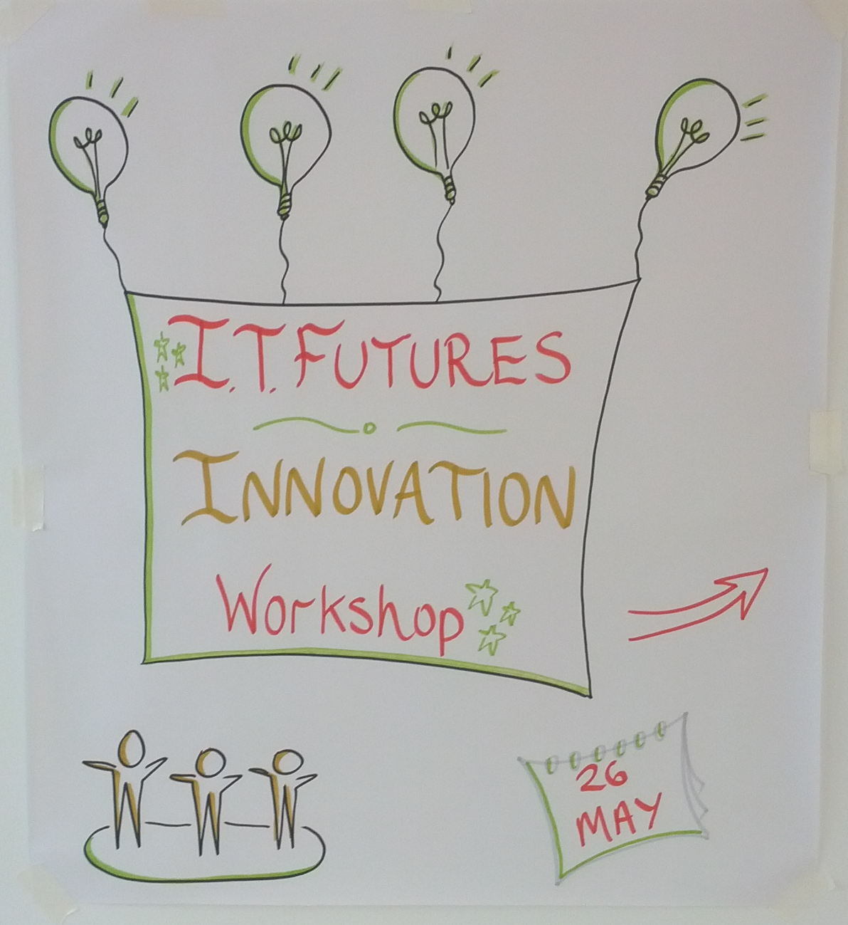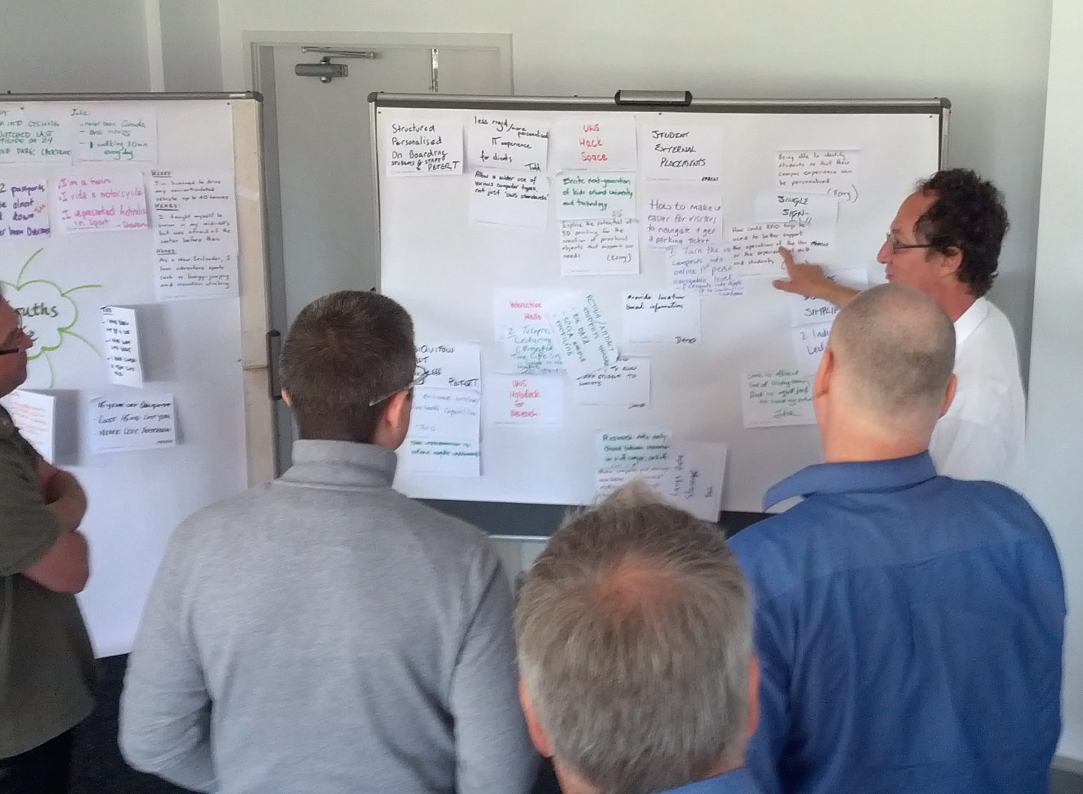
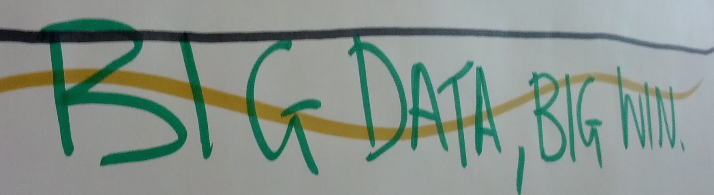

-- HIE. Tim Sutton sorted with OpenNX
-- HIE. Chris Cazonelli sorted with logins
-- HIE. Still working the DC21 upgrade

-- External: NICTA (webrtc hackfest? Chris & Sylvia), Google (for July design meeting), UTS (Ben on Thursday).

-- HDR S.of.Science (data) Janice Withnall hopefully sorted with Peter Wilcockson (Campus IT), with passworded. read-only ownCloud folder, shared and URL shortened. eg. goo.gl/RqbYW5
-- HDR S.of.Medicine (compute) Galaxy walkthrough with Michelle this Thursday.

-- Students: Google Summer of Code Week 1, Zoomin “Chinese Street View” rough project plan up on g.drive. He’s preparing for a Siggraph Asia presentation in June week 1.
-- Students: Professional Experience coming to a close, student presentations next week June 6. Final cluent meeting this Thursday. Mina, Scott, Arrun, Yunnan, & Vinh.
-- Students: CompSci Advanced. Cameron, Nick, Fraser, Dan kicking along.

